Preparing an IDS/SIDS
Preliminary work – Reviewing and prepping the matter for an IDS
- Log into FIP
- Determine whether an IDS/SIDS can be filed at this time:
  - Check that the matter is Pending
  - Check that the matter has not received a Notice of Allowance or Final Office Action
    - IDS/SIDS can be filed even if the matter has received a NOAR or FOAR but it is rare and tricky.
  - Check that the matter has unmarked references
- Ensure that all references that need to be cited have been entered into FIP
  - In each matter that requires a SIDS go to the related matters screen. All related matters must have their references checked and updated.
    - Make sure that all prosecution documents filed in each matter have been entered as references.
    - Make sure that all references cited in any prosecution documents have been entered as references.
    - Check to see if any US related matters may also require an IDS/SIDS at this time.
    - Check to see if any US related matters have not previously been cited in a Communication Concerning related or Copending Application (CCCA)
- Ensure that all references to be cited have been entered properly and are ready to be submitted
  - In each matter that requires a SIDS check the unmarked references
    - Ensure that the NPL documents and foreign documents are attached and have translations or English abstracts.
    - Ensure that all of the references are entered in the required SLW format.
    - Ensure that there are no duplicate references.
Merge the documents and preparing the IDS
- Open Sidebar
- Click on the “merges” tab
- Enter the matter number into the “Matter #” box
- Check to see that “Merge Roles” is set to IDS-Other
- If necessary click merge next to “Header - Communication Concerning Prior or Copending Applications”
  - Select any Green (Not Red or Blue) highlighted US applications (NOT PRV or USA)
- Click Merge next to “IDS – 1449 Form”
  - Note the number of documents in the pop up box (look quickly, it will disappear).
  - Thoroughly examine the 1449 look for and fix any errors including Misspelled references, improperly entered references, or any other errors.
    - Make all corrections in FIP
    - If you make any corrections re-merge 1449
- Click Merge next to “IDS – Communication”
  - Fill out the form

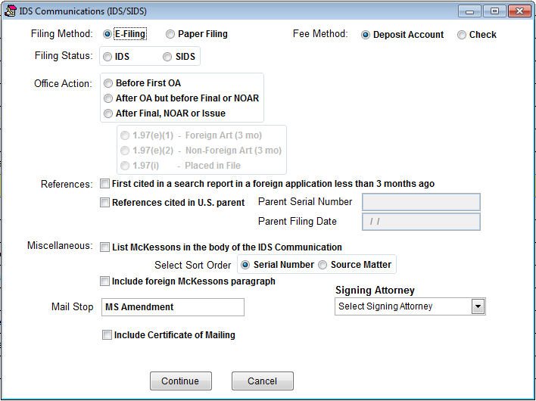

- Click merge next to “Transmittal – General”
  - Fill out the form

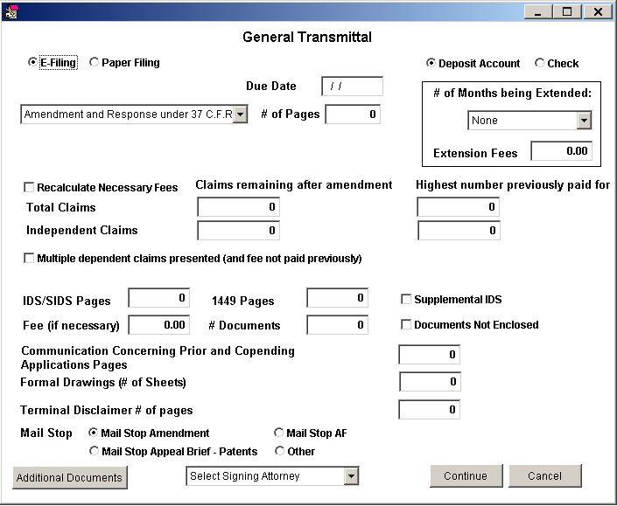

- Save all documents to Worldox
  - Transmittal
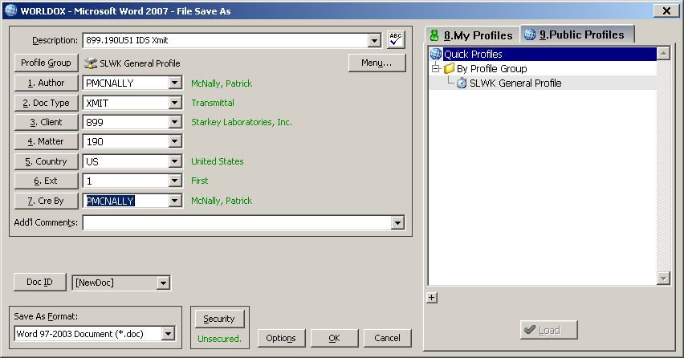
  - CCRA
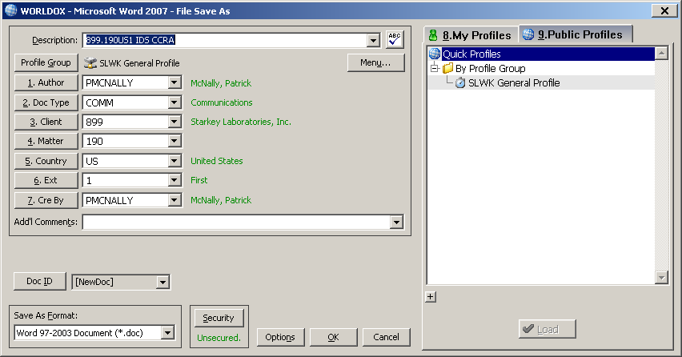

  - Communication
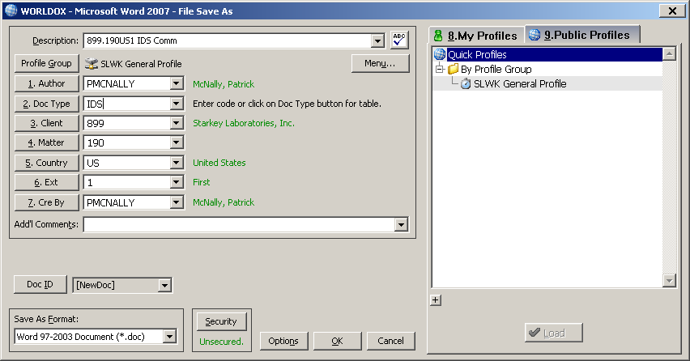

  - 1449
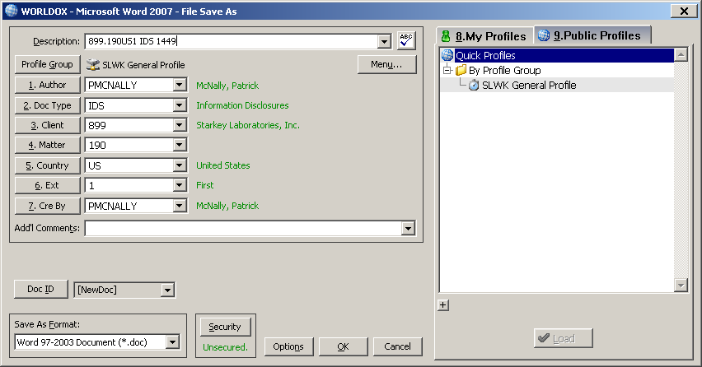
- Download all saved documents from Worldox
- Combine all documents together into one PDF (Order below)
  - Xmit
  - CCRA
  - Comm
  - 1449
- Send email to attorney for signature
  - CC the IDS Specialist
  - Subject line = “<Matter Number> - Documents for signature”
    - Add “ASAP” If necessary. Also, if necessary, check the “High Importance Flag”
  - Body
    - I have prepared an IDS/SIDS for <Matter Number>. I prepared the IDS/SIDS to cite the received document and all currently unmarked references in FIP. If this is satisfactory, please sign and return the attached document. If not, please let me know what changes you would like made.
  - Attach the document
  - Send

Filing the SIDS
- Once you have received the signed document back from the attorney you can begin filing.
- Save the signed copy (I recommend creating a folder for each matter)
- Check the document
- Make sure the attorney signed everywhere required
- Make sure there are no errors
- Make sure the month in the signature block is correct
- Add your own signature and name
- Flatten the document (Print through PDF995).
- Go to the matter in FIP
- Check to make sure the status of the matter has not changed
- Go to the references screen
    - Make sure there are no new references
    - Download all foreign and NPL references for submission.
      - Check to make sure all references were saved
      - Check to make sure the number of references downloaded matches the number of files in the folder.
- Open Sidebar
- Click on the “Toolbox” Tab
- Click on “IDS Tools”
- Enter the matter number into the “Matter #” box
- Click “Get References”
- Click Bulk Rename
- Click through prompt
- Flatten all references
- Set default printer to PDF995
- Make sure all Adobe windows are closed
- Highlight all the references
- Right click the references – Select “Print”
- Wait. This can take some time
- Check the resulting references
- Make sure the number of flattened files matches the number of originals.
- Make sure they are all still renamed
- Make sure no file is larger than 25 MB
- Open a new window and login to USPTO – EFS
- Certification Page
    - Check the box for “I certify that I am working under the authority of the certificate holder: <NAME HERE>”
    - Check the box for “Existing application/patent
      - Check the box for “Document/Fees for an existing application
        - Fill in the information. This information can be found either on the documents you are filing (Upper right corner) or in the matter in FIP under “Details”.
    - Click continue
    - Attach Documents Page
    - Select the signed PDF fill out the fields appropriately (example below)
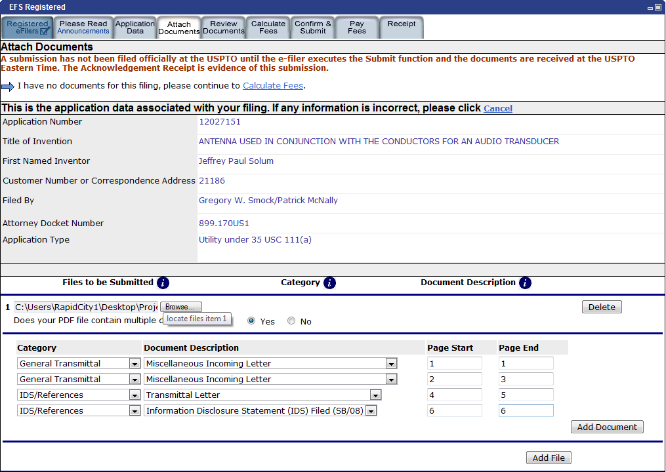
      - Upload and validate the Signed SIDS document
    - Click Attach Files
      - Add all references to be submitted as files.
        - For Foreign Publications select “IDS/References” and Foreign Reference”
        - For NPL documents select “IDS/References” and NPL
      - You can only submit 20 documents and one time and only 60 per filing.

    - Check for any errors
      - Documents over 25 MB
        - Open the file in Adobe
        - Click “Document”
        - Click “Reduce file size”
        - Select “Acrobat 7.0 or later”
      - Unembeded Font
        - Flatten document – If printing through PDF995 doesn’t work contact me.
      - Pages size to large
        - Flatten document
- Calculate Fees Page
    - You shouldn’t have to do anything here as any IDS/SIDS you are filing should be free.
- Submit Application Page
    - Check everything over one last time – Click Submit
- Receipt page
    - Save the E-filing receipt.

Update FIP
- Go to the matter in FIP.
- SIDS activity (If one does not exist create one)
- Click edit for the unfinished SIDS activity.
      - Fill in the dates for filing and e-filing receipt received.
      - Click Save
- Click on the open folder for the SIDS activity
- Add the submitted SIDS as a document
        - Leave Subject selection as “Other”
- Add the E-filing receipt as a reference
        - Change Subject section to “Confirmation”
- Click the green calculator for the SIDS activity
- Add billing for preparation
- Enter Code
          - P37 for IDS
          - P38 for SIDS
- Add time billed
- Add client billing code if necessary
- Add billing for filing
  - p42 is the code for filing
- Go to the references screen mark all references cited as cited
- CCRA Activity (Only if you filed a CCRA)
- Create CCRA Activity (Code = CCRA)
- Add document
- Add billing
  - Enter Code: P40
  - Add time as billed
  - Add client billing code if necessary
- Go to related matters screen and mark all cited matters as cited

